Review Application Build

Problem
By the time I have progressed to this stage, there are approximately 5,000+ generated songs on my SSD.
Various review approaches have been used, not across this entire catalogue but on targeted samples as different generation methods and models have been tried. To date the largest sample review was conducted across 1,000 songs and was a simple single score system with ratings applied by moving songs into specific directories. This is a slow process that does not adequately measure the range of different qualities a song can have.

Solution
I will address both the single scoring and time consuming aspects of generation review with a single tool.
We will now measure a generations quality across four metrics:
- Audio Quality : how polished is the sound? Does it contain noise, glitching or unwanted audio artifacts?
- Composition : does the song match its captioned genre? Inspired by it at least? Or does it jump from one genre to the next in each section?
- Consistency : does the song remain consistent throughout, or does the first half sound like a different song to the second half?
- Realism : how likely is it that the average person would hear the song and know that it was AI generated?
These measures will provide valuable insight into the generation parameters, both linguistic parameters like the caption and lyrics as well as the systematic parameters like CFG, sampling steps, scheduling etc.
The analysis of the data captured will inform parameter assignment for future song generations.

Build
With a significant backlog to review, I need this built quickly and do not want to spend significant time or effort in learning additional coding skills or libraries to write this review application end-end.
I constructed the following prompt, and supplied it to Chat GPT-6, set on medium effort, with the request that it writes my design up into a formal structured prompt made for Chat GPT-6.1 Sol Max, who would then build the application:
Document: _P_Tooling.txt
It returned the following formatted instruction:
Document: _P_Tooling_Build_Instruction.txt
I supplied this, without modification, to Chat GPT-6.1 Sol Max.

54 minutes later, it had built the complete application, along with installation instructions and a gap/issue analysis (no surprises inside)
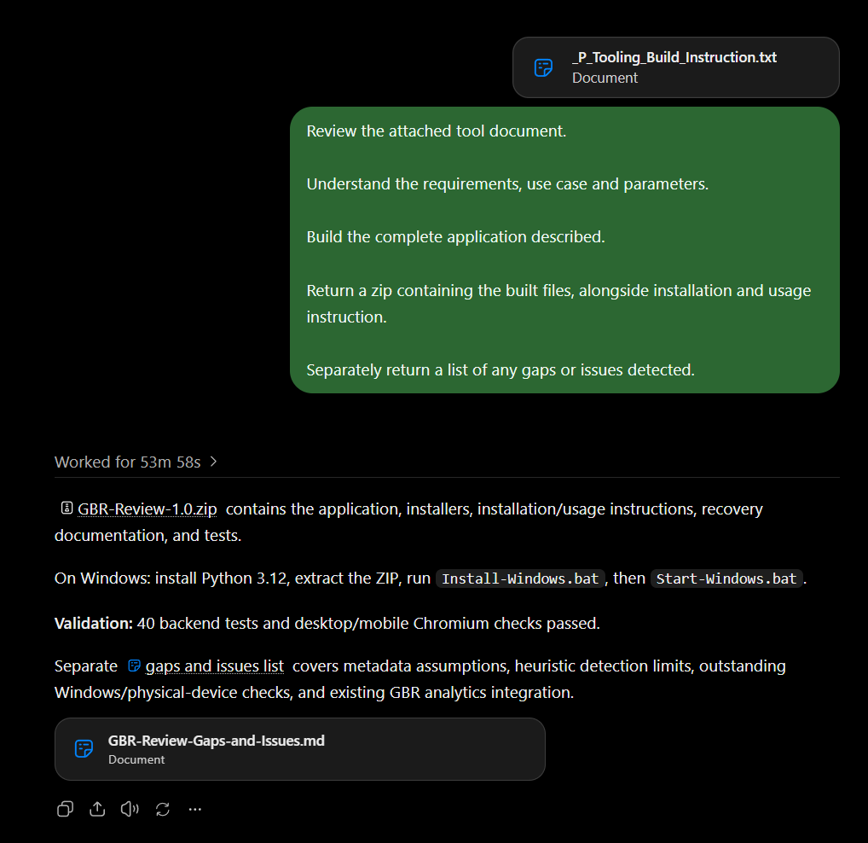
The application operated largely in-line with my highest expectation, with only one bug in the build. I captured the console log output and supplied this back to 6.1, along with a request to resolve the bug, which it did with a further 13 minutes of work.
67 minutes of its time had a fully working review tool which I started using to classify my generated songs.
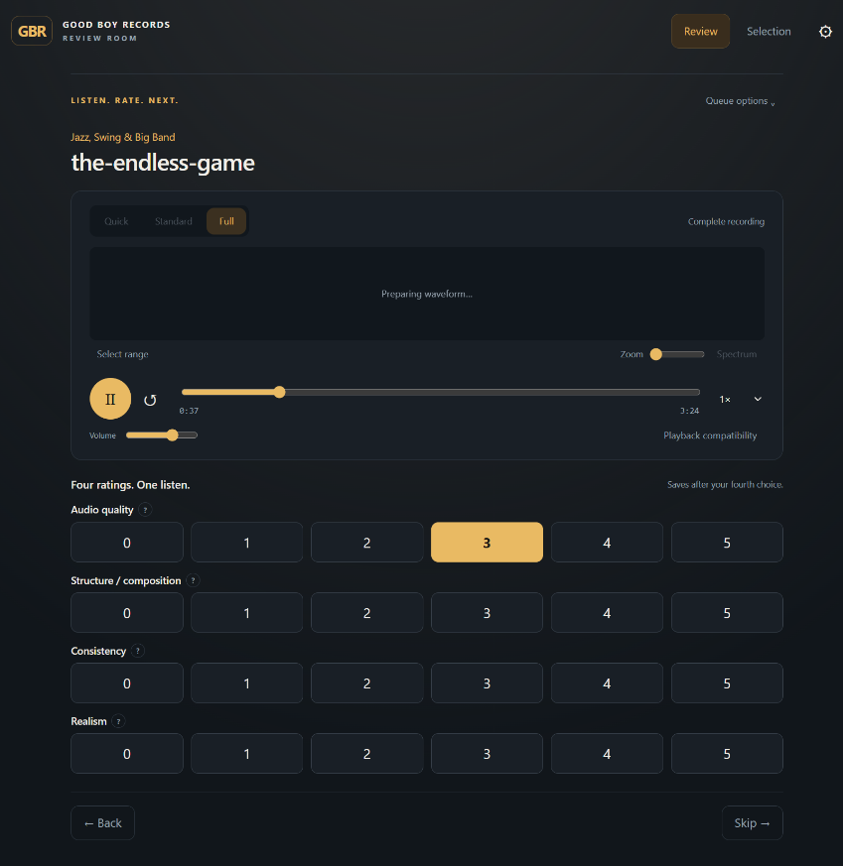
After reviewing approximately 100 songs, I had built a small list of adjustments I wanted making to the application. Which across three different prompts submitted to 6.1 took a further 99 minutes to resolve.

Feature List
Meaning our total 6.1 build time now sits at 2 hours 46 minutes.
That time has given me an application which:
- Runs locally on my desktop PC, where the songs are located
- HTML interface
- Configuration paraments:
  - Which directories to load songs from
  - Which directory to archive reviewed songs in
    - Songs are automatically moved into one of 6 folders based on the mean score applied
  - What order to review songs in (random, alpha-numeric, date created)
- 4 simple 0-5 rating scale buttons
- Pre-defined points of interest, where the tool has been able to algorithmically detect shifts in the songs structure, potential clipping etc, or other noticeable changes in structure, loudness or tempo
- Multiple playback modes
  - Full song : plays in a style similar to most media players, starts at the start, ends at the end
  - Standard : plays through 50 seconds of the song, clipping to the points of interest
  - Fast : plays through 20 seconds of the song, clipping to the points of interest
- Mobile interface, mobile devices can connect via the LAN to the application, so I can be away from my desktop completing chores around the house, whilst listening to generated songs and inputting my review scores
- Multi-user reviews enabling more than one person to review generated songs at the same time, with automated queuing of review lists to ensure each reviewer is not being provided songs that other active reviewers have/are reviewing
- SQL database of reviewed tracks, storing unique identifiers, review scores, reviewer ID
- Flagging of generations which are suitable for publishing to GBR, this flag gets picked up by the next stage in the process
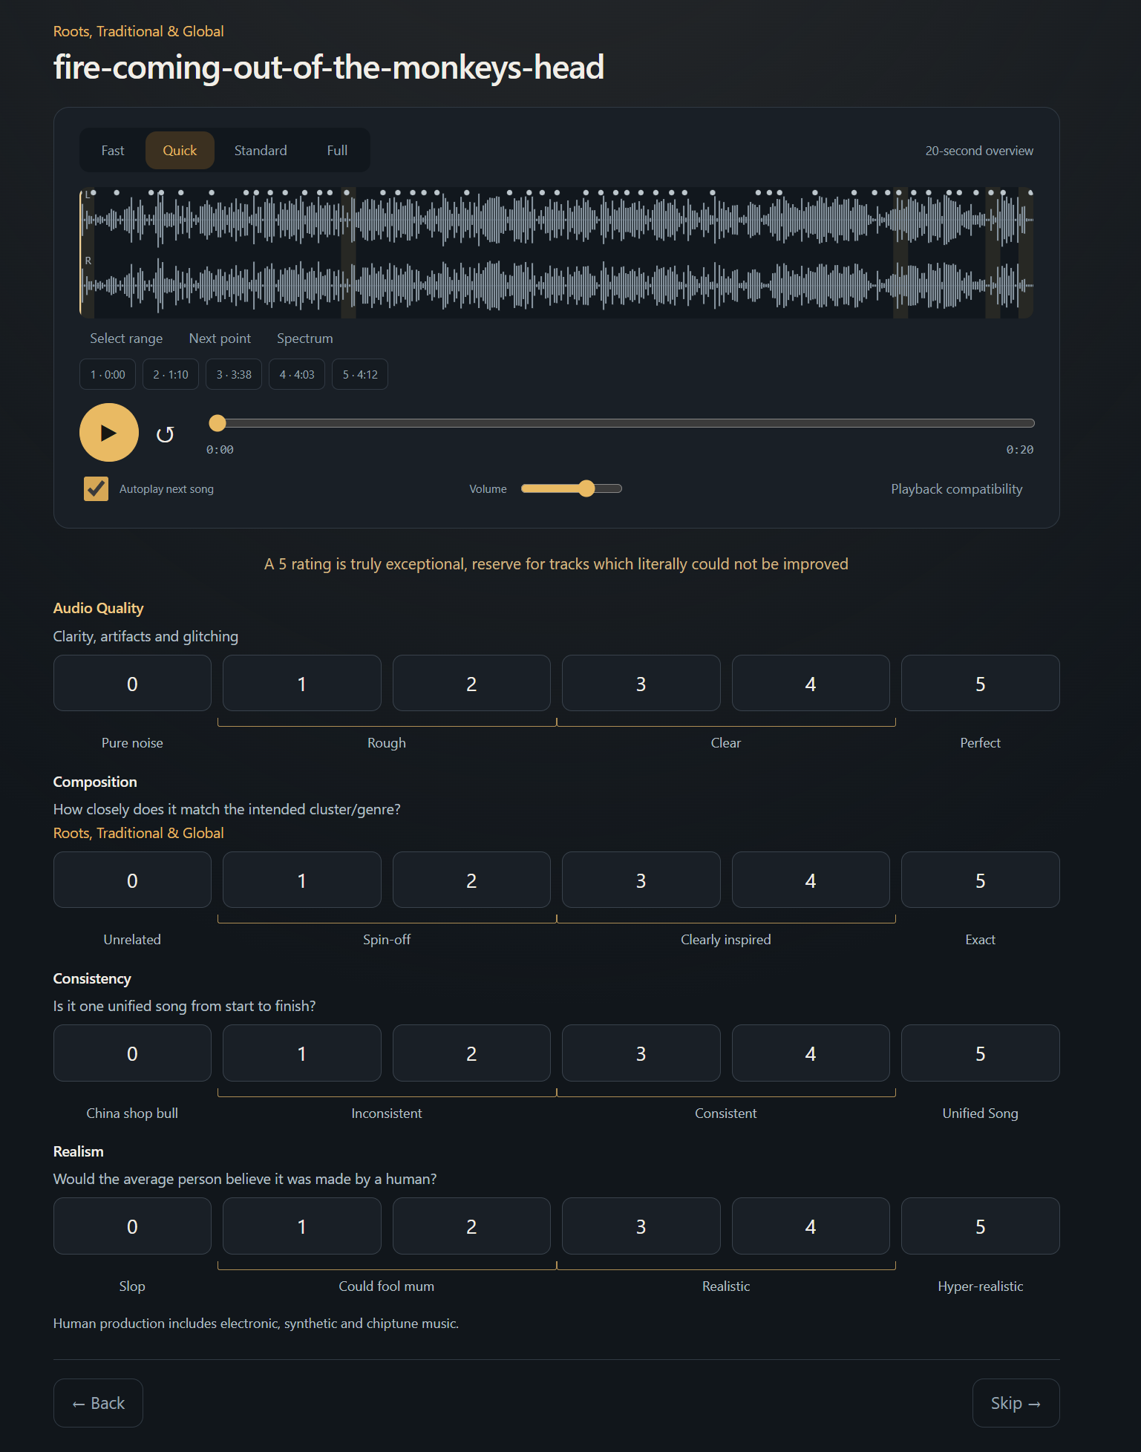
Desktop
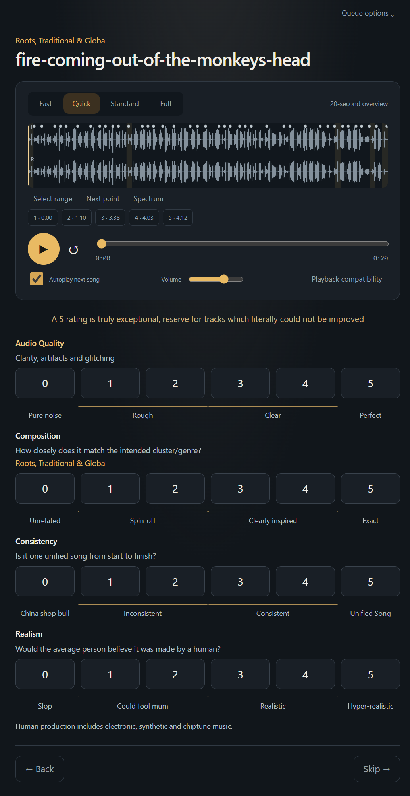
Mobile

Output
As mentioned, all results are stored inside an sqllite database.
The database was designed by 6.1 as part of the build request.
The schema is shown below, as captured in DbVisualizer, the rough structure is designed around the generations themselves.
